
Portfolio of evidence
Part 1


Name: Princesse Laurie Erika
Surname: Megha
Student number: ST10497718
Group: 1
Module: Introduction to Web Development
Module Code: WEDE5020
Due date: 20th April 2026
Lecturer: Kamanga Albert
Table of Contents
1. Organisation Overview 2
2. Website goals and objectives 2
3. Current Website Analysis 3
4. Proposed Website features and functionality 3
5. Design and User Experience 3
6. Technical requirements 6
7. Timeline and Milestones 6
8. Budget 7
References 8

Organisation Overview
Name: HairbyAmbre
HairbyAmbre is an independently owned hairstyling business that offers a variety of services including braiding, wig instalments, locs, sew in and hair treatments and Tv/sets hires. Her business operates though social media platforms with bookings made on a third-party system; Fresha. (@hairby_ambre, 2020)
- Mission and Vision
To provide hairstyling services that gives clients confidence in their look. We also envision to become a trusted hairstylist with a strong online presence to showcase her work and make booking appointments easier for clients.
- Target audience
Amber aims to young women and students. She also is open to be hired by working professionals for collabs and sets hire.

Website goals and objectives
Right now, potential clients must switch between Instagram and a booking app to see the styles which is inconvenient.
- Goals
Centralise all information in one website
Showcase services
Simplify booking process
Improve online presence
- KPIs
Website visits
Enquiries submitted
Bookings completed
Client engagement

Current Website Analysis
- Current strengths
Active Instagram, functional booking system, direct client contact.
- Weaknesses
No central hub, users must switch platforms, booking may require an account

Proposed Website features and functionality
- Homepage: Overview
- About: About Ambre
- Services: List of services with prices
- Gallery: Portfolio
- Contact: Email, phone, Instagram
- Booking and Enquiry: Enquiry form and book now button(to Fresha)

Design and User Experience
- Colour scheme: Black, gold and grey
- Typography: Century Schoolbook
- Layout and design: Image-focused, easy navigation
Wireframes:
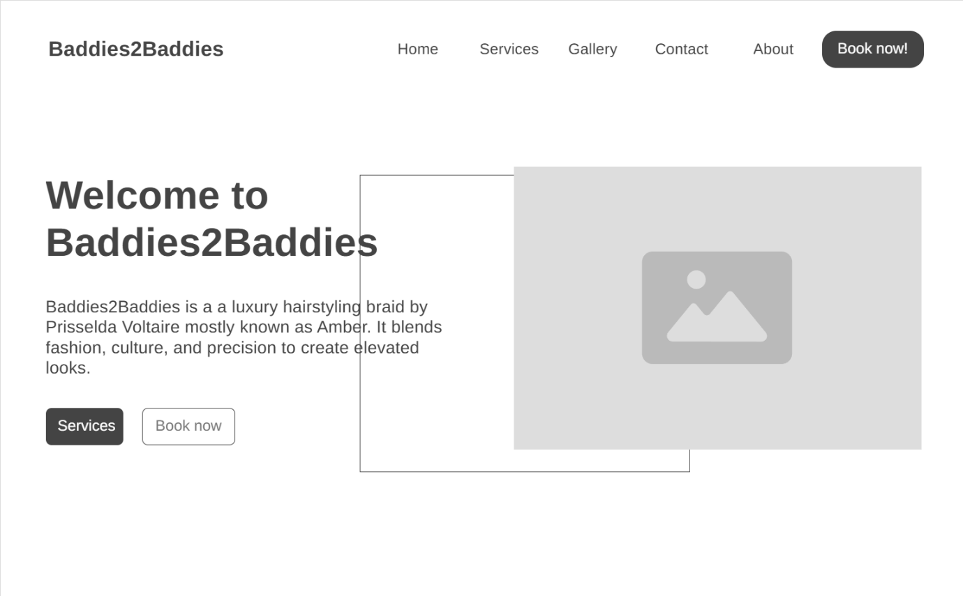
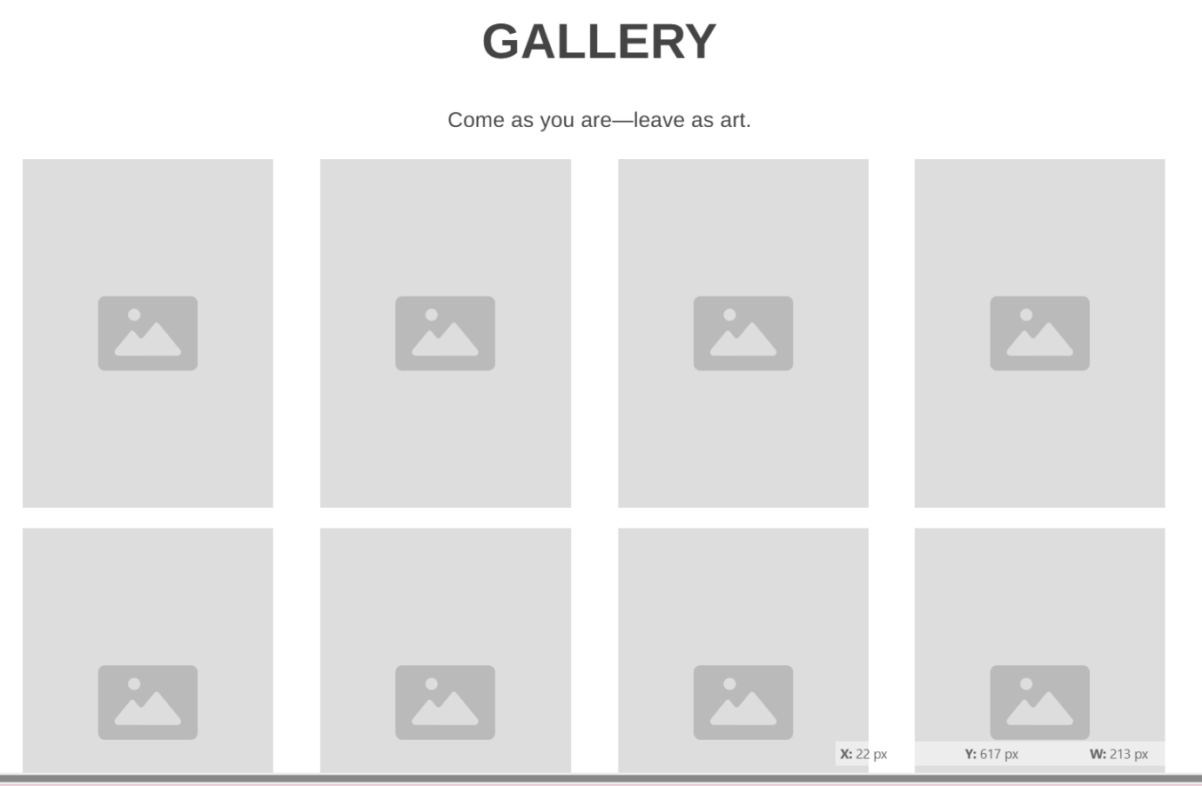
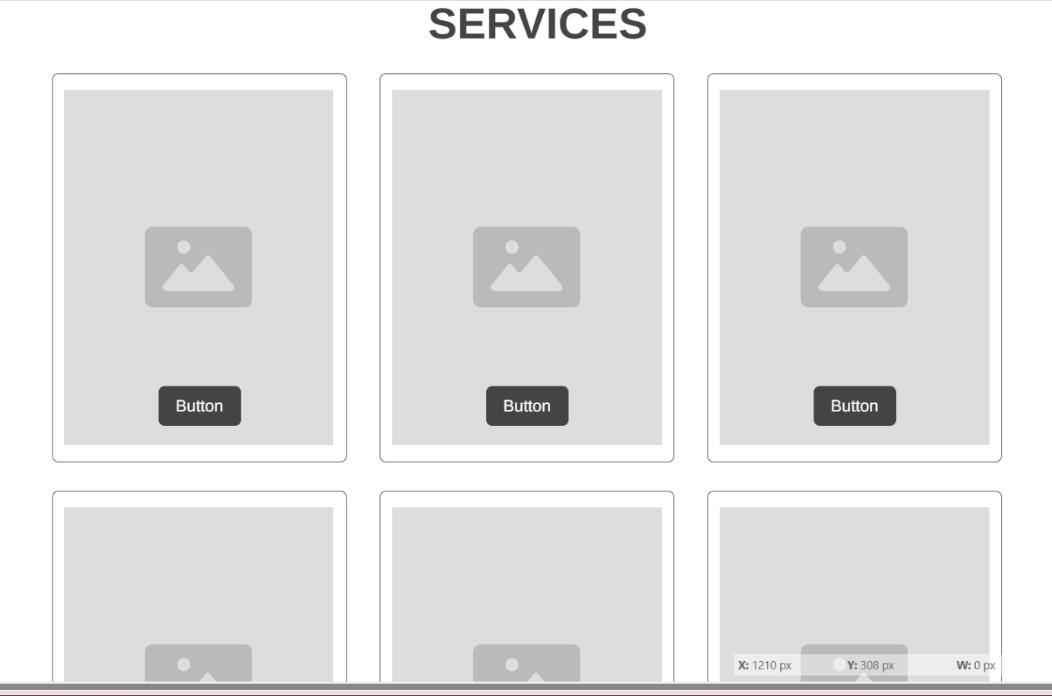
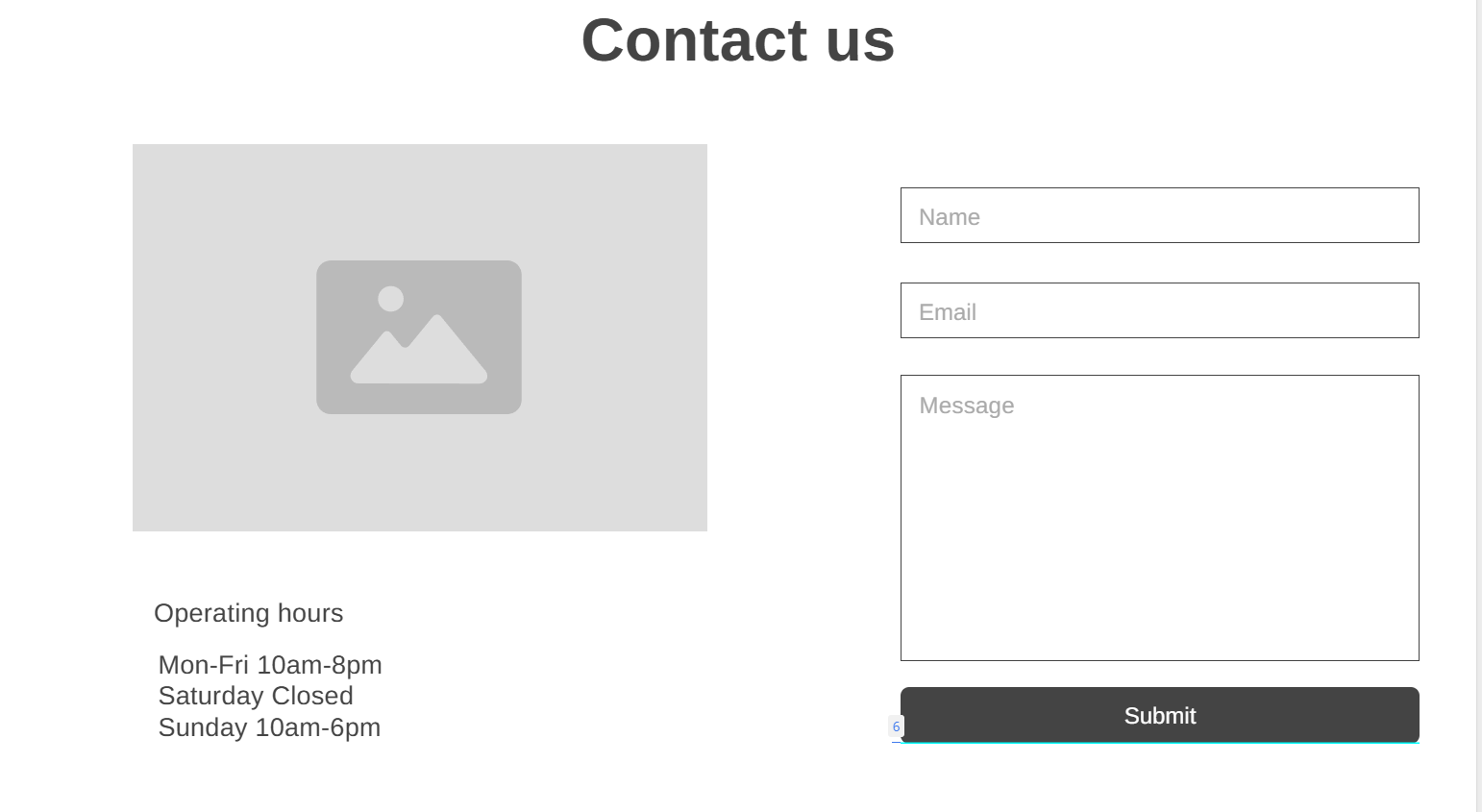
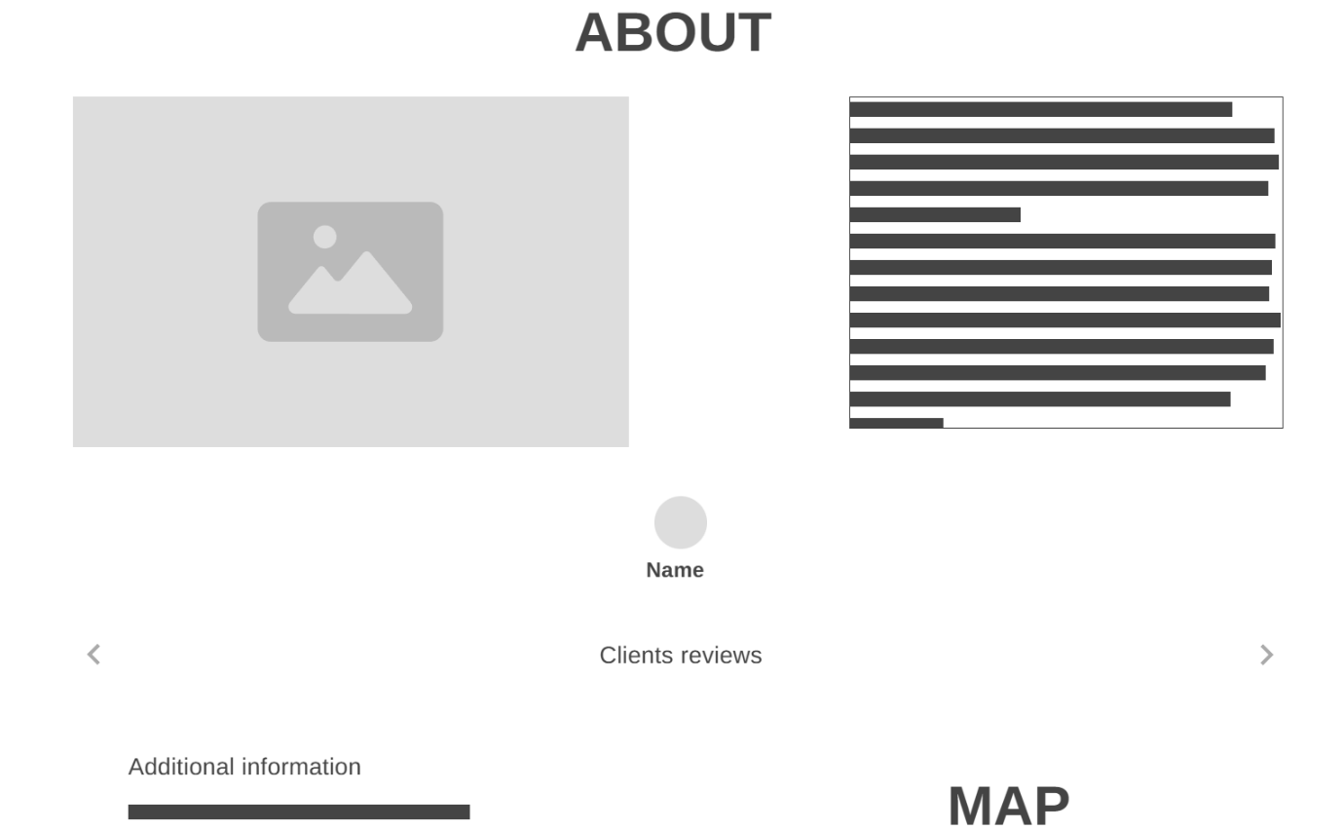

Technical requirements
- HTML
- CSS
- JavaScript
- Domain

Timeline and Milestones
Week 1- 2: Research, social media sourcing
Week 3-4: Building the wireframes and the basic HTML structure
Week 5-6: CSS styling and adjustments
Week 7-8: Responsive design
Week 9: JavaScript Implementation
Week 10: Final testing and adjustments

Budget
- Development: R2500 - R5000(once-off)
- Domain: R90 – R250 per year for a standard .co.za
- Hosting: R299 - R499 per month
- Maintenance: R299 - R499 per month
(S., 2026)

References
@hairby_ambre, 2020. @hairby_ambre. [Online]
Available at: https://www.instagram.com/hairby_ambre/#
[Accessed 11 April 2026].
S., A., 2026. How Much Does It Cost to Build a Website in South Africa?. [Online]
Available at: https://hostafrica.co.za/blog/websites/website-basics/how-much-does-a-website-cost-in-south-africa/#breakdown-of-website-costs-in-south-africa
[Accessed 10 April 2026].

